Health Check – How Am I Going?

Interpreting Your Results—At the completion of your Self-Assessment survey you are provided with feedback about how you are going across various domains of health. (If you haven’t yet completed the Self-Assessment you can access that here). That feedback can be emailed to you and printed for your records. It is best to read your feedback in conjunction with the guidance provided below and the Staying at the Top of Your Game resource. Remember, this information is provided as a guide only. Please contact a relevant practitioner for a more detailed assessment of your health needs.
If you have immediate concerns about how you are going, ring the confidential NZDF helpline 0800 NZDF4U (0800 693348 or text 8881). For general health concerns contact your GP (or regional Defence Health Centre or if you are serving), the national Healthline 0800 611 116, or Text or call free 1737 for free 24/7 telehealth support.

Next steps
Use the feedback and your own thoughts to fill in the tables below to map how you are going across each domain. Put a tick under the column that best represents how you’re going in each area—going great, going OK–but an opportunity for further improvement, or an area for focus.
Remember that each area is important for your overall health, and that factors within each domain (such as nutrition, exercise, sleep, alcohol use, social support, sense of fulfilment, job satisfaction and life events) can act as risk or protective factors.
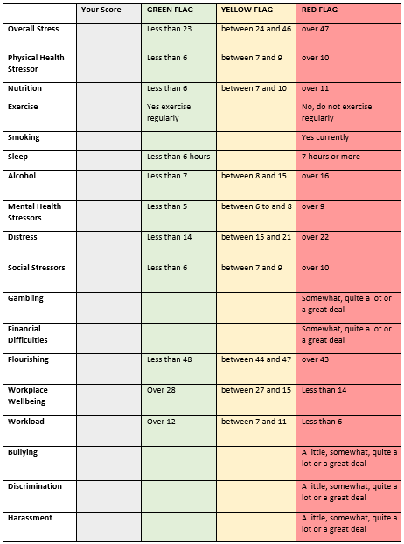

Now take a look at “Your Health Profile”. Consider where you are doing well and where there is opportunity or need to improve.
- Where you rate areas in the yellow or red zones, what actions can you take?
- What are your priorities? What are the first things you want to focus on that may be foundations for next steps?
- Can you take these actions yourself or do you need a helping hand?
Use the templates on the next pages to develop your plan of action.
Remember to draw on tips and tools and support resources available in Staying at the Top of Your Game and Take Action to help you do this. Check out Making and sustaining changes.

Your Health Profile

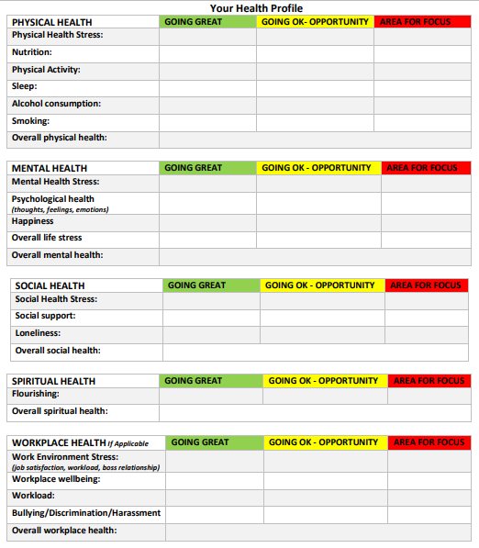
ACTION PLAN
What new habit do you want to achieve?
Make sure your actions lead to specific and measurable outcomes (your goals).
Read more about Setting goals and making a plan of action
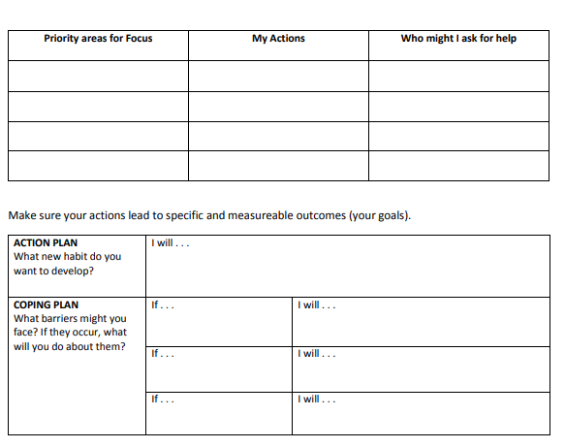
Action Plan – these are the steps you are going to take to reach your goals.
I will . . .

Staying on track: Sometimes we start with good intentions but things get in the way. It’s a good idea to think about what some of these ‘derailers’ might be, and what you can do about them.
What barriers might you face? If they occur, what will you do about them?
If . . . I will . . .
If . . . I will . . .
If . . . I will . . . Looking after yourself

Test and Adjust: Initiate your plan and then review. How are you going? Acknowledge and celebrate even small steps. Adjust your plan if need be. Asking for a helping hand if you are feeling stuck.
Your toolkit
Use the resources on this site for a helping hand in particular areas and check out the tips below as a reminder of things that people often find helpful for maintaining wellbeing.
Attitudes
- Accept that it can take time to make changes
- Accept that there are some things you have no control over
- Understand what might be worrying you and work out a plan to manage those things that are within in your control
- Reframe your thinking – Turn “I can’t cope” into “I can cope. There are some things I can’t completely control but I will deal with them as they arise”
- If you can, try to be organised and efficient so you have some time to yourself
- Keep your mind focused on the here and now
- Spend time reflecting on what you are grateful for / positive things that (most always) happen each day
Physical
- Do regular physical exercise such as walking, swimming, cycling
- Make an effort to reduce or at least not to increase your intake of stimulants such as
alcohol, tobacco and sugar as they keep the stress cycle going
- Get plenty of rest
- Eat regular, well balanced meals even if they are small. Focus on “real”, unprocessed food.
- Maintain your levels of Vitamins B, C, and E as these help keep us mentally and physically resilient
- Drink plenty of water
Relationships
- Keep regular contact with people you like to be with
- Ask for help when you need it, many people enjoy giving help
- Make time to be with your family or friends
- Listen to others (sometimes they pick up things going on for you better than you do)
- Talk to people you trust about yourself and what is happening – they can help get it into
perspective
Relaxation
- Do regular relaxation exercises such as deep breathing, listening to quiet music, mindfulness, meditation
- Help manage body tension through massage or exercise
- Rest regularly, even if you can only do it for a short time
- Try to find something that will make you laugh… and if you can’t, laugh anyway!
You’ve got this. And remember that if you would like to speak to someone about how you are going you can contact a Defence Health Centre, your GP or confidential helplines - 0800 NZDF4U (0800 693348) or Healthline 0800 611 116.
You can also find a list of other useful contacts, websites and tools here.

